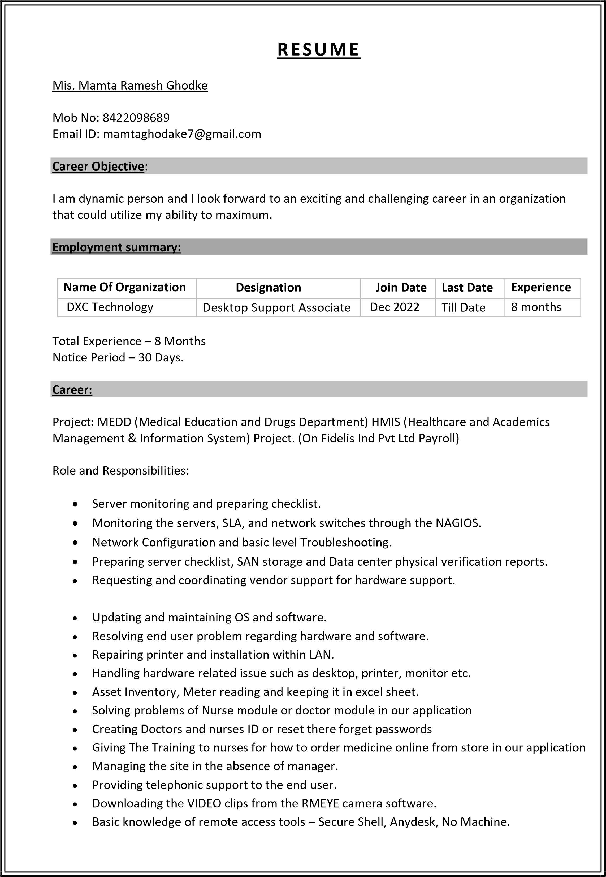

* 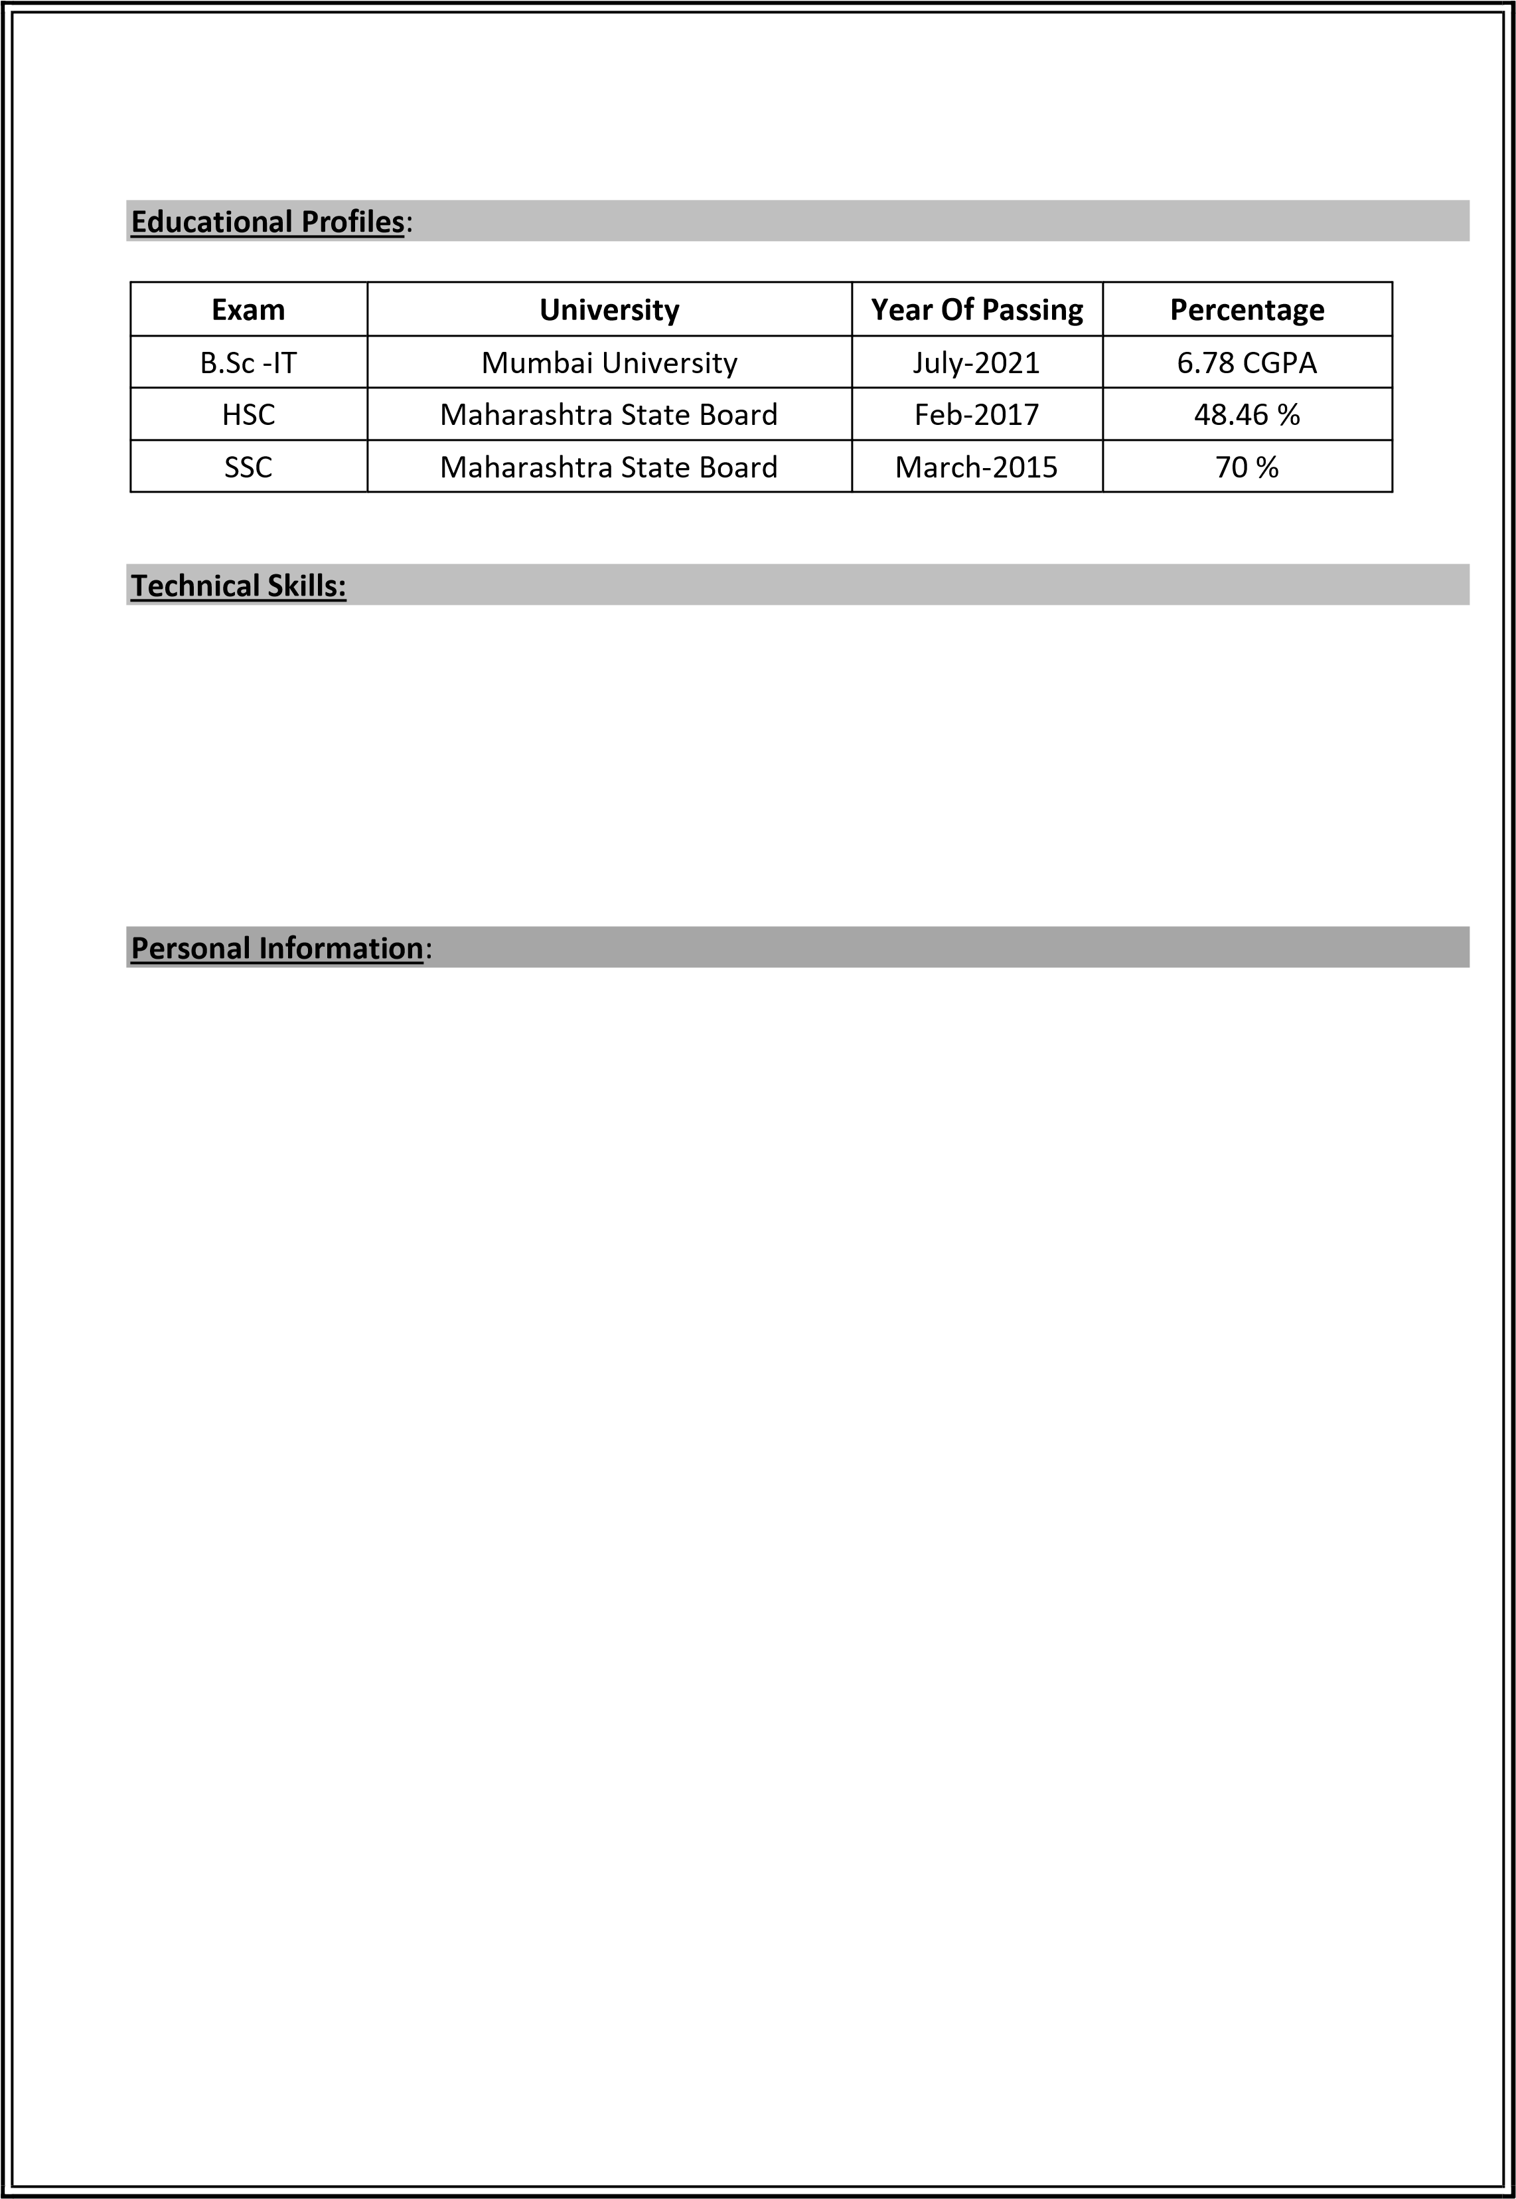MSCIT
* Basic knowledge of computer.
* Basic computer troubleshooting.
* Software installation.
* Operating System - Windows 7, 8, 10 and Rhel.
* MS Office(Excel, word, PowerPoint)

Father’s Name: Mr. Ramesh Sakharam Ghodke

Mother’s Name: Mrs. Sujata Ramesh Ghodke

Permanent Address: Railway colony B/R,8/5, RB -1 , sec 22 Juinagar Navi Mumbai

Date of Birth: 08 June 2000

Languages known: Marathi, Hindi, English.

Marital Status: Unmarried.

Hobbies: Dancing ,Books Reading

Strengths: Hard working and good learning skill.

Date :-

Place :- Mumbai Mis. Mamta Ghodke